**1. function.php**

<?php

session_start();

define("DB_HOST", "localhost");

define("DB_USER", "root");

define("DB_PASSWORD", "Pratik@1607");

define("DB_DATABASE", "loginregister");

$conn = mysqli_connect(DB_HOST, DB_USER, DB_PASSWORD, DB_DATABASE);

// IF

if(isset($_POST["action"])){

if($_POST["action"] == "register"){

register();

}

else if($_POST["action"] == "login"){

login();

}

}

// REGISTER

function register(){

global $conn;

$name = $_POST["name"];

$username = $_POST["username"];

$password = $_POST["password"];

if(empty($name) || empty($username) || empty($password)){

echo "Please Fill Out The Form!";

exit;

}

$user = mysqli_query($conn, "SELECT * FROM tb_user WHERE username = '$username'");

if(mysqli_num_rows($user) > 0){

echo "Username Has Already Taken";

exit;

}

$query = "INSERT INTO tb_user VALUES('', '$name', '$username', '$password')";

mysqli_query($conn, $query);

echo "Registration Successful";

}

// LOGIN

function login(){

global $conn;

$username = $_POST["username"];

$password = $_POST["password"];

$user = mysqli_query($conn, "SELECT * FROM tb_user WHERE username = '$username'");

if(mysqli_num_rows($user) > 0){

$row = mysqli_fetch_assoc($user);

if($password == $row['password']){

echo "Login Successful";

$_SESSION["login"] = true;

$_SESSION["id"] = $row["id"];

}

else{

echo "Wrong Password";

exit;

}

}

else{

echo "User Not Registered";

exit;

}

}

?>

**2. index.php**

<?php

require 'function.php';

if(isset($_SESSION["id"])){

$id = $_SESSION["id"];

$user = mysqli_fetch_assoc(mysqli_query($conn, "SELECT * FROM tb_user WHERE id = $id"));

}

else{

header("Location: login.php");

}

?>

<!DOCTYPE html>

<html lang="en" dir="ltr">

<head>

<meta charset="utf-8">

<title>Index</title>

</head>

<body>

<h1>Welcome <?php echo $user["name"]; ?></h1>

<a href="logout.php">Logout</a>

</body>

</html>

**3. login.php**

<?php

require 'function.php';

if(isset($_SESSION["id"])){

header("Location: index.php");

}

?>

<!DOCTYPE html>

<html lang="en" dir="ltr">

<head>

<meta charset="utf-8">

<title>Login</title>

</head>

<body>

<h2>Login</h2>

<form autocomplete="off" action="" method="post">

<input type="hidden" id="action" value="login">

<label for="">Username</label>

<input type="text" id="username" value=""> <br>

<label for="">Password</label>

<input type="password" id="password" value=""> <br>

<button type="button" onclick="submitData();">Login</button>

</form>

<br>

<a href="register.php">Go To Register</a>

<?php require 'script.php'; ?>

</body>

</html>

**4. logout.php**

<?php

require 'function.php';

$_SESSION = [];

session_unset();

session_destroy();

header("Location: login.php");

?>

**5. register.php**

<?php

require 'function.php';

if(isset($_SESSION["id"])){

header("Location: index.php");

}

?>

<!DOCTYPE html>

<html lang="en" dir="ltr">

<head>

<meta charset="utf-8">

<title>Register</title>

</head>

<body>

<h2>Register</h2>

<form autocomplete="off" action="" method="post">

<input type="hidden" id="action" value="register">

<label for="">Name</label>

<input type="text" id="name" value=""> <br>

<label for="">Username</label>

<input type="text" id="username" value=""> <br>

<label for="">Password</label>

<input type="password" id="password" value=""> <br>

<button type="button" onclick="submitData();">Register</button>

</form>

<br>

<a href="login.php">Go To Login</a>

<?php require 'script.php'; ?>

</body>

</html>

**6. script.php**

<script src = "https://ajax.googleapis.com/ajax/libs/jquery/3.2.1/jquery.min.js">

</script>

<script type="text/javascript">

function submitData(){

$(document).ready(function(){

var data = {

name: $("#name").val(),

username: $("#username").val(),

password: $("#password").val(),

action: $("#action").val(),

};

$.ajax({

url: 'function.php',

type: 'post',

data: data,

success:function(response){

alert(response);

if(response == "Login Successful"){

window.location.reload();

}

}

});

});

}

</script>

**Output**

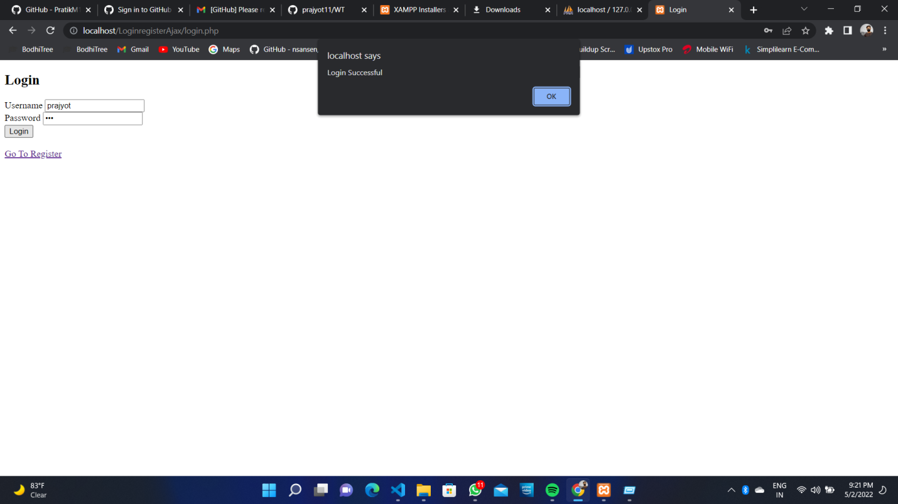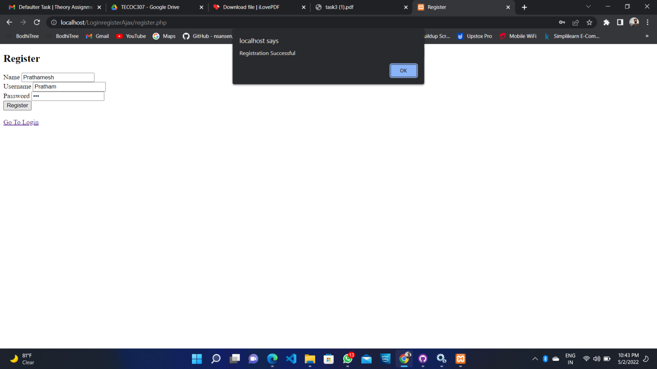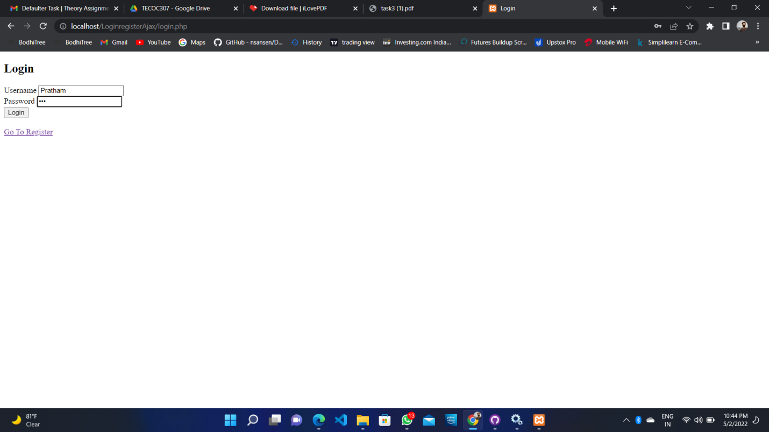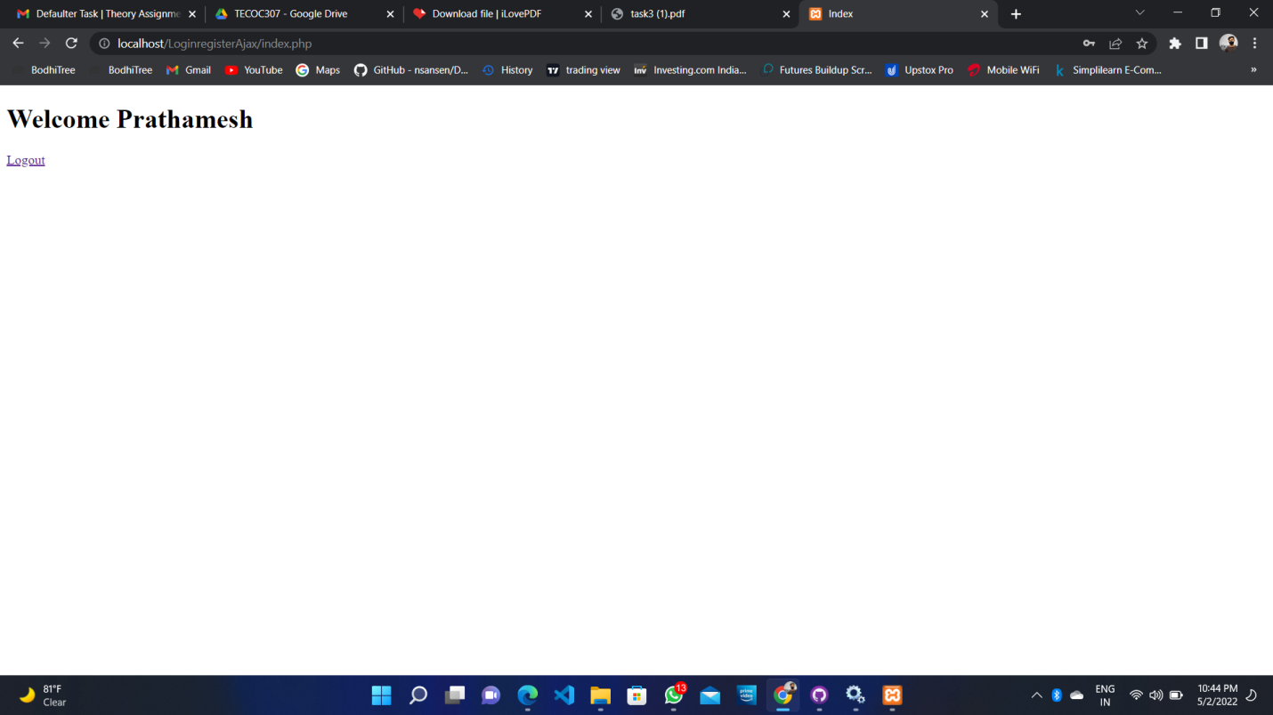

Github Link : - https://github.com/pratham3001/WT